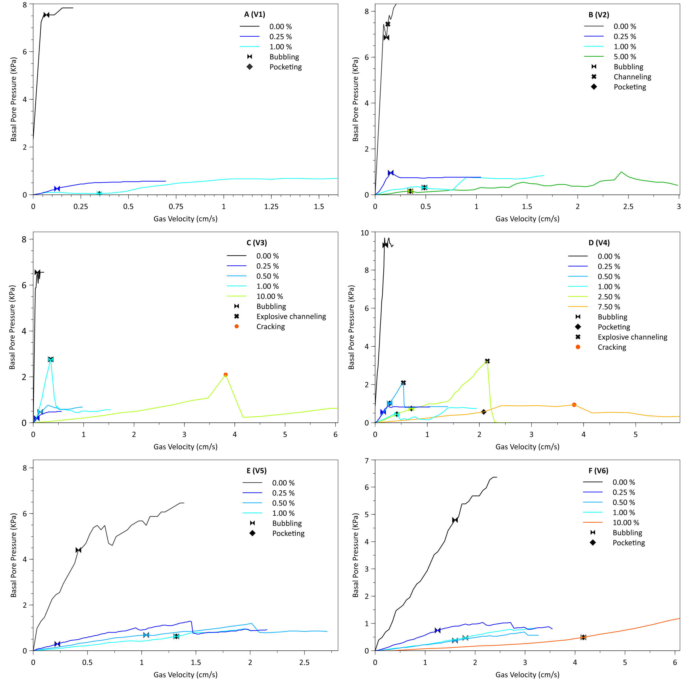

**Fig. A-F** Fluidisation profiles of V1 – V6 with increasing moisture (0.00 – 10.00 %). Symbols show gas escape structure formation